Лабораторна робота 8
Тема: Знайомство з найпростішими типами макетів.
Хід роботи
Завдання1: Реалізувати 8 сторінок з макетами різного типу, використовуючи ідеї, описані в теоретичних відомостях. При цьому на сторінках розмістіть власний контент, використайте кольори та зображення на власний розсуд.

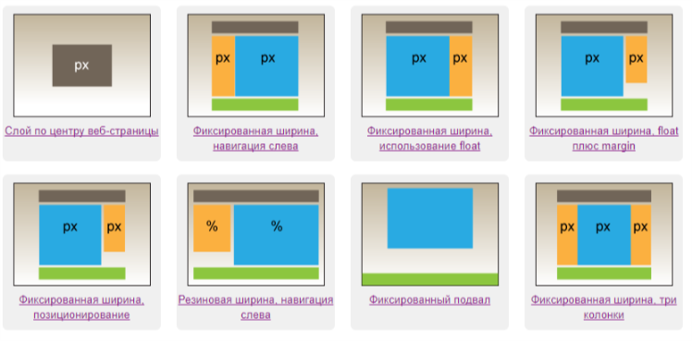
Шаблон 1
Лістинг файлу index.html
<!DOCTYPE html>
<html lang="en">
<head>
<meta charset="UTF-8">
<title>Document</title>
<link rel="stylesheet" type="text/css" href="style.css">
</head>
<body>
<div class="body">
<img src="./img/christmas-tree.png" alt="">
</div>
</body>
</html>
Лістинг файлу style.css
.body{
width: 500px;
height: 500px;
margin: 0 auto;
margin-top: 200px;
font-size: 25px;
background: url(./img/christmas-colour.png);
border: 2px solid green;
}
img{
height: 480px
}

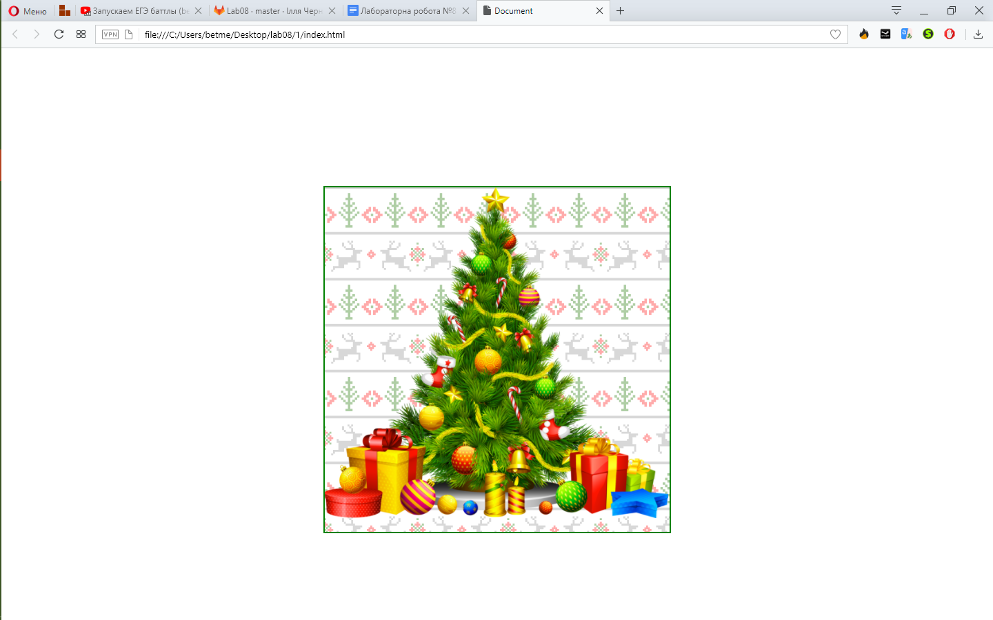
Рис. 8.1 – Вигляд першого шаблону
Шаблон 2
Лістинг файлу index.html
<!DOCTYPE html>
<html>
<head>
<meta charset="utf-8">
<title>CyberSport</title>
<link rel="stylesheet" type="text/css" href="style.css">
</head>
<body>
<div id="body">
<div class="header">
<a href="index.html"><img src="./img/WCGlogo.jpg"></a>
</div>
<div class="menu">
<p><a href="https://www.hltv.org/events/851/wcg-2011">Статистика турнира</a></p>
<p><a href="https://www.hltv.org/player/4218/Dav">MVP турнира</a></p>
<p><a href="https://www.hltv.org">Новости</a></p>
</div>
<div class="content">
<p>
<span>Lorem ipsum dolor sit amet, consectetur adipisicing elit. Ea iste quod saepe. Nemo saepe excepturi eius, nostrum culpa, iusto id dicta, reiciendis quam eligendi assumenda animi labore obcaecati maiores minima.</span>
<span>Quod, recusandae sed exercitationem soluta voluptatum, rem iste ea, laborum ab consectetur quam accusantium in inventore itaque voluptas dolorum perferendis? Sapiente cupiditate magnam quo facere laboriosam, earum illum, commodi officiis.</span>
<span>Aspernatur omnis molestias dolorum ratione voluptate, nostrum culpa nesciunt maiores voluptas dolores fugit dolore illum saepe dignissimos. Iusto quisquam recusandae, sint at, aut nostrum molestias aliquid, ad alias minima enim.</span>
<span>Repudiandae molestias inventore totam, numquam obcaecati ex perspiciatis odio, veniam iste recusandae. Voluptate voluptates sed ducimus fugit soluta, est dignissimos unde ullam, saepe delectus praesentium ad, iure quos maxime nisi?</span>
<span>Aspernatur facere accusantium at aliquid. Nisi tenetur amet placeat corporis veniam, pariatur distinctio accusamus ratione velit similique ut, perferendis adipisci eius officia ad, corrupti earum tempore error. Qui, assumenda, molestiae!</span>
</p>
</div>
<div class="footer"> WCG 2011</div>
</div>
</body>
</html>
Лістинг файлу style.css
body {
background: #eee;
margin: 0;
padding: 0;
}
h2 {
font-size: 1.1em;
color: #800040;
margin-top: 0;
}
#body {
width: 500px;
margin: 0 auto;
background: #f0f0f0;
}
.header img{
width: 500px;
box-shadow: 2px 2px 100px #444;
}
.header a:hover{
box-shadow: 0 0 100px #1ff;
}
.header {
display: block;
}
.header h1 {
font-size: 2.2em;
text-align: center;
color: #ffe;
margin: 0;
}
.menu {
margin-top: 10px;
width: 110px;
padding: 0 10px;
float: left;
}
.menu a{
text-decoration: none;
font-size: 20px;
}
.menu p{
border: 1px solid black;
text-align: center;
}
.menu p:hover{
box-shadow: inset 0 0 3px #123;
}
.content {
display: block;
margin-left: 130px;
padding: 10px;
background: #fff;
}
.content p {
margin-top: 0.3em
}
.footer {
display: block;
color: gray;
padding: 5px;
text-align: center;
border: 1px solid;
}

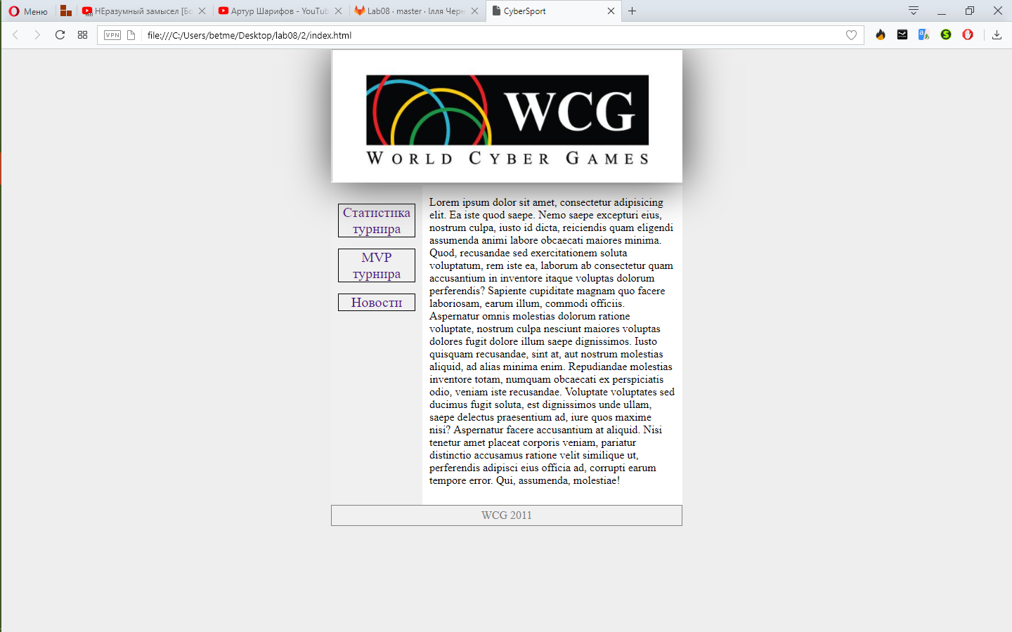
Рис. 8.2 – Вигляд другого шаблону
Шаблон 3
Лістинг файлу index.html
<!DOCTYPE html>
<html>
<head>
<meta charset="utf-8">
<title>IEM Katowice</title>
<link rel="stylesheet" type="text/css" href="style.css">
</head>
<body>
<div id="container">
<div class="header">
<img src="./img/IEMKatowiceHeader.jpg">
</div>
<div class="content">
<h1>IEM Katowice</h1>
<img src="./img/Group.png">
<p> Intel® Extreme Masters will visit Katowice for the fifth year in a row. In March 2017, IEM will bring the best gaming action to the Spodek Arena with Counter-Strike: Global Offensive, StarCraft II and League of Legends. The tournaments that take the stage in Katowice feature the world's most talented progamers.</p>
<img src="./img/NaviWiner.jpg">
</div>
<div class="menu">
<p><a href="#">Глваная</a></p>
<p><a href="#">Сетка</a></p>
<p><a href="#">Група А</a></p>
<p><a href="#">Група В</a></p>
<p><a href="#">Игра дня</a></p>
<img src="./img/Intel.png">
</div>
<div class="clear"></div>
<div class="footer">
<img src="./img/ESLfooter.png" alt="ESL">
</div>
</div>
</body>
</html>
Лістинг файлу style.css
.header, .footer {
display: block;
}
body {
font: 10pt Arial, Helvetica, sans-serif;
background-image:url(./img/gaming-pattern.png);
margin: 0;
}
#container {
width: 500px;
margin: 0 auto;
background: #f0f0f0;
}
.header {
background: #8fa09b;
}
.header img{
width: 500px;
}
.content {
overflow:auto;
float: left;
width: 330px;
padding: 10px;
border-right: 1px dashed black;
background: white;
text-align: center;
}
.content img {
width: 300px;
}
.menu {
float: left;
width: 120px;
padding: 10px;
text-align: center;
}
.menu a{
text-decoration: none;
color: black;
font-weight: bold;
}
.menu img{
padding-top: 20px;
width: 120px;
}
.menu p:hover{
box-shadow: 0 0 10px #111;
}
.menu p{
padding: 5px;
border: 1px solid black;
}
.footer{
text-align: center;
}
.footer img{
width: 70px;
}
.clear {
clear: both;
}
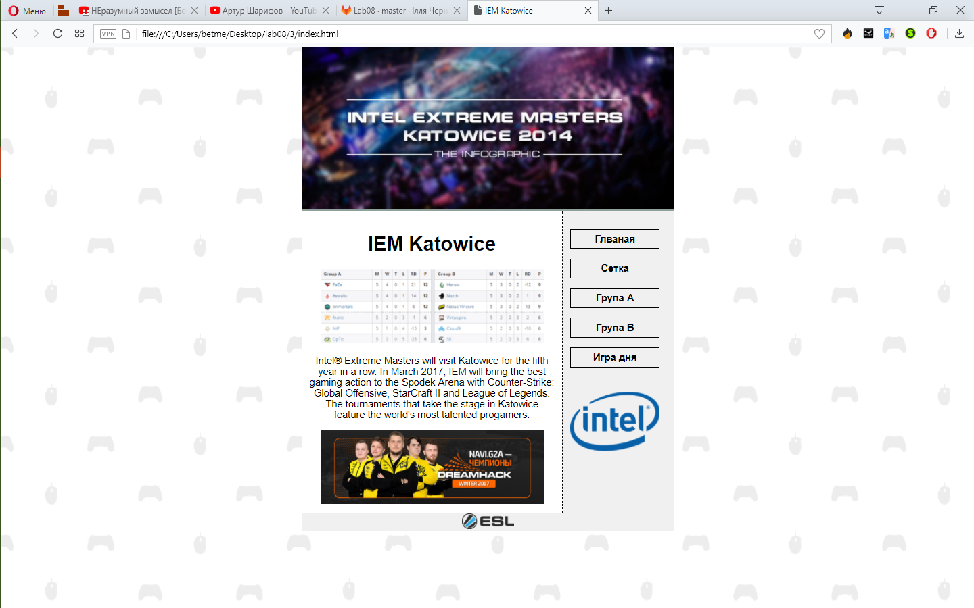
Рис. 8.3 – Вигляд третього шаблону
Шаблон 4
Лістинг файлу index.html
<!DOCTYPE html>
<html>
<head>
<meta charset="utf-8" />
<title>DH17</title>
<link rel="stylesheet" type="text/css" href="style.css">
</head>
<body>
<div id="container">
<div class="header"><img src="./img/header.png"></div>
<div class="menu">
<p><a href="#">Что такое DH</a></p>
<p><a href="#">Групы</a></p>
<p><a href="#">Как попасть</a></p>
</div>
<div class="content">
<h1>DREAMHACK OPEN RETURNS TO DHS17</h1>
<p>DreamHack Open will return once to DreamHack Summer 2017 and bringing CS:GO to the masses is something we are always excited about. $100,000 will be on the line for eight teams that will battle it out in front of a huge crowd.</p>
<img src="./img/NAVIwin.jpg">
</div>
<div class="footer"><img src="./img/DreamHack.png" alt=""></div>
</div>
</body>
</html>
Лістинг файлу style.css
body {
font: 10pt Arial, Helvetica, sans-serif;
background-image: url(./img/halftone-yellow.png); ;
margin: 0;
}
#container {
width: 500px;
margin: 0 auto;
}
.header img {
width: 500px;
}
.content {
margin-right: 140px;
padding: 10px;
text-align: center;
}
.content img {
width: 340px;
}
.menu {
float: right;
width: 120px;
padding: 10px;
}
.menu a{
text-decoration: none;
color: black;
font-weight: bold;
}
.menu p:hover{
box-shadow: 0 0 10px #111;
}
.menu p{
padding: 5px;
border: 1px solid black;
}
.footer{
text-align: center;
}
.footer img {
height: 30px;
}
.header,.menu,.content,.footer {
display: block;
}
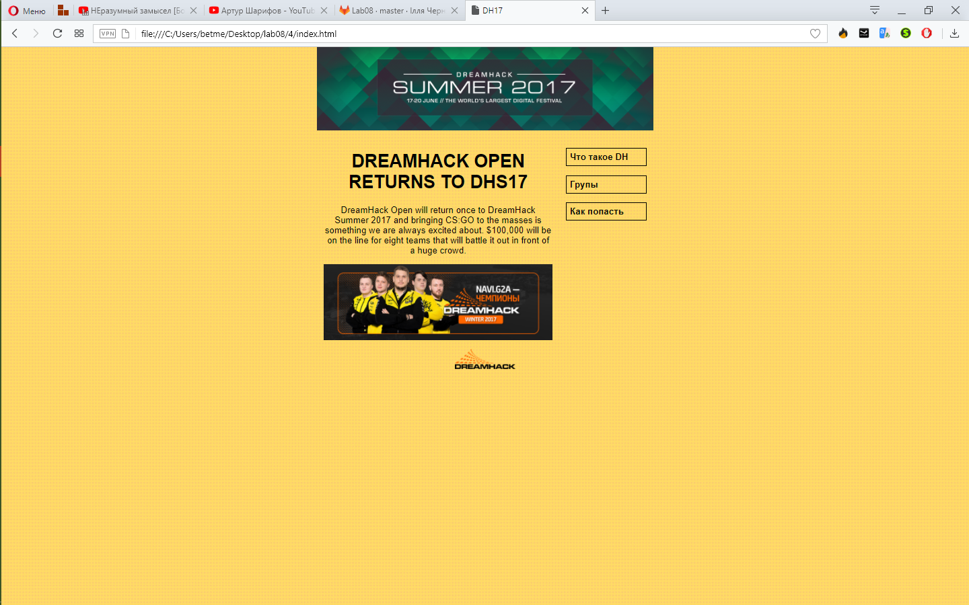
Рис. 8.4 – Вигляд четвертого шаблону
Шаблон 5
Лістинг файлу index.html
<!DOCTYPE html>
<head>
<meta charset="utf-8">
<title>WOW</title>
<link rel="stylesheet" type="text/css" href="style.css">
<body>
<div id="body">
<div class="header">World of WarCraft</div>
<div class="content">
<h1>Battle for Azeroth</h1>
<p>Get ready to journey into Antorus, the Burning Throne. This brand-new raid houses 11 challenging bosses and powerful new rewards, including class tier sets, formidable trinkets, and more. Raid Preview · Buy Legion Now. Latest News Updates. View all news. December 6th, 2017. We Need You on the </p>
<img src="./img/worldofwarcraft.jpg">
</div>
<div class="menu">
<p><a href="https://www.youtube.com/watch?v=Xv1JzYDKoc8">Посмотреть трейлер</a></p>
<p><a href="https://worldofwarcraft.com/ru-ru/battle-for-azeroth">Подробнее</a></p>
<p><a href="https://worldofwarcraft.com/ru-ru/return">Азерот нуждается в вас</a></p>
<p><a href="https://battle.net/wow/legion/">Приобрести</a></p>
</div>
<div class="footer">
<img src="./img/blizLogo.png" alt="Blizzard">
</div>
</div>
</body>
</html>
Лістинг файлу style.css
body {
font: 10pt Arial, Helvetica, sans-serif;
background-image: url(./img/tex2res4.png);
margin: 0;
}
#body {
width: 500px;
margin: 0 auto;
position: relative;
}
.header {
background-image: url(./img/wowheader.jpg);
font-size: 24pt;
font-weight: bold;
color: #edeed5;
padding: 5px;
}
.content {
background-color: lightgray;
margin-right: 130px;
padding: 10px;
border-right: 1px dashed #183533;
text-align: center;
}
.content p {
margin-top: 0.3em
}
.content img{
width: 300px;
}
.menu {
position: absolute;
right: 0;
top: 60px;
width: 120px;
text-align: center;
}
.menu a{
text-decoration: none;
color: black;
font-weight: bold;
}
.menu p:hover{
box-shadow: 0 0 10px #111;
text-shadow: 0 0 2px #ddd;
}
.menu p{
padding: 5px;
border: 1px solid black;
background-color: lightgray;
}
.footer {
text-align: center;
}
.footer img{
width: 50px;
}
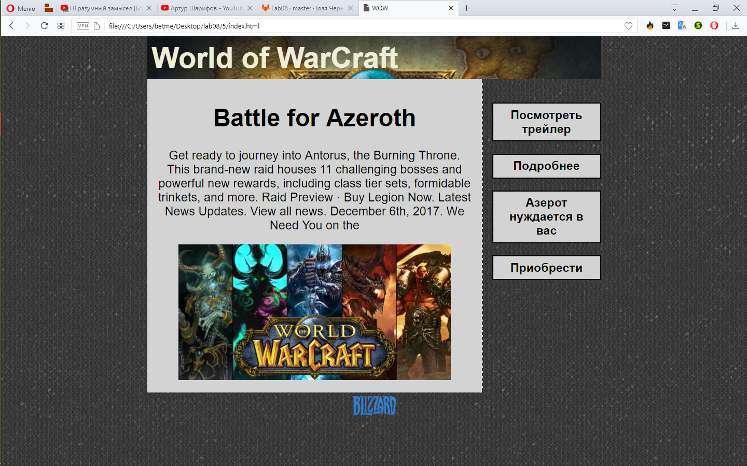
Рис. 8.5 – Вигляд п’ятого шаблону
Шаблон 6
Лістинг файлу index.html
<!DOCTYPE html>
<html>
<head>
<meta charset="utf-8">
<title>Life Is Strange</title>
<link rel="stylesheet" type="text/css" href="style.css">
</head>
<body>
<div class="header">
<img src="./img/life_is_strange_header.png" alt="Life is Strange">
</div>
<div class="menu">
<p><a href="http://store.steampowered.com/app/319630/Life_is_Strange__Episode_1/">Episode 1</a></p>
<p><a href="http://store.steampowered.com/app/329880/Life_is_Strange__Episode_2/">Episode 2</a></p>
<p><a href="http://store.steampowered.com/app/329910/Life_is_Strange__Episode_3/">Episode 3</a></p>
<p><a href="http://store.steampowered.com/app/329920/Life_is_Strange__Episode_4/">Episode 4</a></p>
<p><a href="http://store.steampowered.com/app/329930/Life_is_Strange__Episode_5/">Episode 5</a></p>
</div>
<div class="content">
<h2>First Episode </h2>
<p>Life is Strange is an award-winning and critically acclaimed episodic adventure game that allows the player to rewind time and affect the past, present and future.
Follow the story of Max Caulfield, a photography senior who discovers she can rewind time while saving her best friend Chloe Price.
The pair soon find themselves investigating the mysterious disappearance of fellow student Rachel Amber, uncovering a dark side to life in Arcadia Bay. Meanwhile, Max must quickly learn that changing the past can sometimes lead to a devastating future.</p>
<img src="./img/background.jpg" alt="photo">
<p>Lorem ipsum dolor sit amet, consectetur adipisicing elit. Itaque inventore laboriosam molestiae aliquam rem enim earum eos, suscipit nesciunt voluptatibus quaerat tempora dolore quidem, quo quam deleniti ullam. Incidunt, quaerat. Lorem ipsum dolor sit amet, consectetur adipisicing elit. Dolorum libero sint provident quod ut maxime voluptas minima labore enim, soluta similique atque laborum nam, nisi cupiditate vero ex excepturi beatae. Lorem ipsum dolor sit amet, consectetur adipisicing elit. Sapiente necessitatibus delectus nihil a tempore neque, veritatis, porro quidem! Est magni explicabo impedit similique, facilis alias, vitae repellat deleniti. Earum, velit. </p>
</div>
<div class="footer">
<img src="./img/DNE-ancien-logo.png" alt="DNE">
</div>
</body>
</html>

Лістинг файлу style.css
body {
font: 11pt Arial, Helvetica, sans-serif;
margin: 0;
}
h1 {
font-size: 36px;
margin: 0;
color: #fc6;
}
.header{
text-align: center;
}
.header img{
width: 300px;
}
.menu {
float: left;
width: 20%;
margin: 0 10px;
text-align: center;
}
.menu a{
text-decoration: none;
color: black;
font-weight: bold;
}
.menu p:hover{
box-shadow: 0 0 10px #111;
text-shadow: 0 0 2px #ddd;
}
.menu p{
padding: 5px;
border: 1px solid black;
background-color: lightgray;
}
.content {
margin: 10px 5px 20px 25%;
padding: 5px;
border: 1px solid #333;
text-align: center;
}
.content img{
width: 500px;
}
.footer {
background: lightgray;
padding: 5px;
color: #fff;
clear: left;
text-align: center;
vertical-align: middle;
}
.footer img{
width: 100px;
}

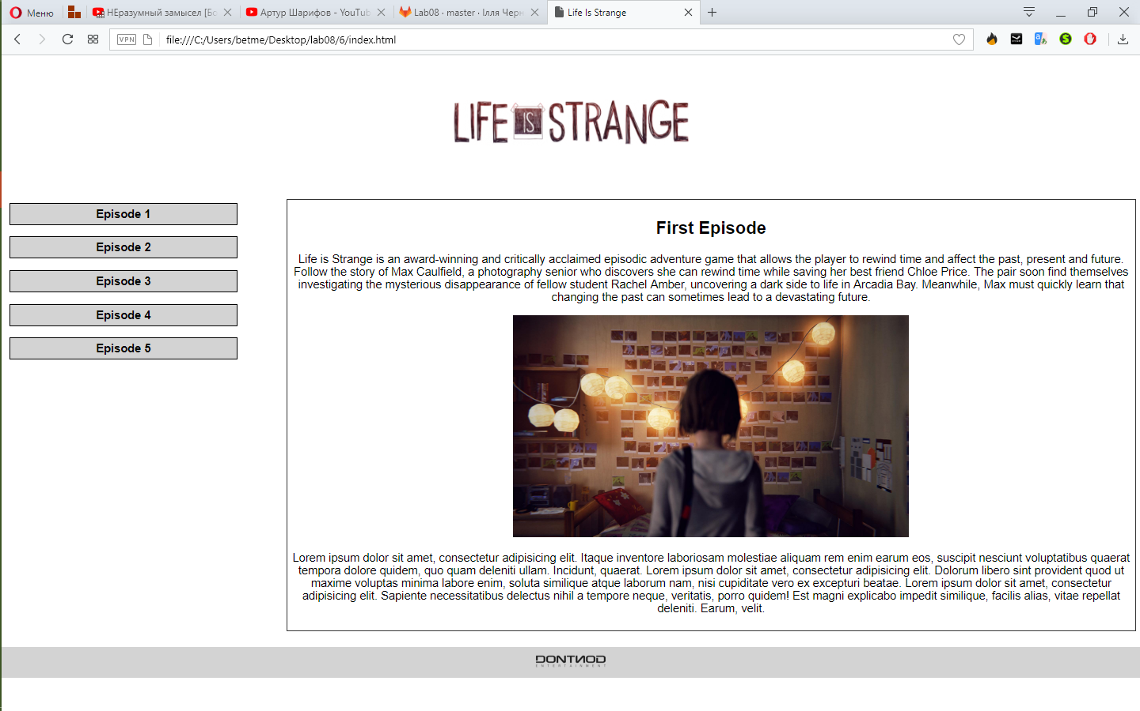
Рис. 8.6 – Вигляд шостого шаблону

Шаблон 7
Лістинг файлу index.html
<!DOCTYPE html >
<html>
<head>
<meta charset="utf-8">
<title>Фиксированный подвал</title>
<link rel="stylesheet" type="text/css" href="style.css">
</head>
<body>
<div class="body">
<div class="content">
<img src="./img/galaga.png">
<div>Lorem ipsum dolor sit amet, consectetur adipisicing elit. Rerum ut, autem, reprehenderit ratione natus ipsum facere obcaecati ex quae eligendi illo necessitatibus dolores reiciendis facilis molestias fugiat harum quia corporis.</div>
<div>Vero ad saepe consequatur quo maxime, quis ea possimus natus magni commodi. Voluptas consectetur, corporis? Voluptate iste asperiores corporis, ipsam porro sint, deserunt sapiente at fugit, qui voluptatum saepe quo.</div>
<img src="./img/sprite.png">
<div>Distinctio corrupti doloribus quod numquam deleniti nostrum, accusantium ratione quasi ipsum sint harum sapiente tenetur odio repellat quos qui ea nisi inventore id provident esse! Magni in libero rem distinctio!</div>
</div>
</div>
<div class="footer">
<div> its<img src="./img/gameover.png">footer </div>
</div></body>
</html>
Лістинг файлу style.css
body {
margin: 0;
background-image: url(subtle_grunge.png);
}
.body {
width: 500px;
margin: 0 auto 50px;
}
.content{
text-align: center;
}
.content img{
width: 300px;
}
.footer {
position: fixed;
left: 0; bottom: 0;
color: #fff;
width: 100%;
text-align: center;
}
.footer div {
padding: 10px;
background: gray;
}
.footer img{
width: 200px;
}

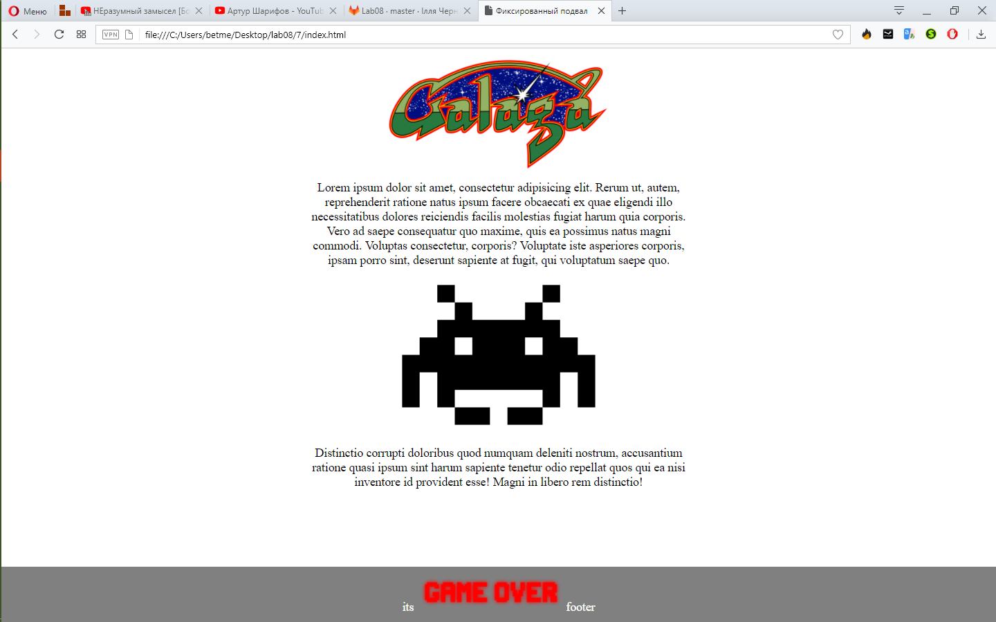
Рис. 8.7 – Вигляд сьомого шаблону
Шаблон 8
Лістинг файлу index.html
<!DOCTYPE html >
<html>
<head>
<meta http-equiv="Content-Type" content="text/html; charset=utf-8" />
<title>HLTV</title>
<link rel="stylesheet" type="text/css" href="style.css">
</head>
<body>
<div class="body">
<div class="header">
<img src="./img/hltvlogo.png" alt="HLTV">
</div>
<div class="menu">
<p><a href="https://www.hltv.org/">Новости</a></p>
<p><a href="https://www.hltv.org/matches">Матчи</a></p>
<p><a href="https://www.hltv.org/results">Результати</a></p>
</div>
<div class="news">
<h3>Новости</h3>
<p><a href="https://www.hltv.org/news/22296/guardian-niko-can-still-be-better-i-think-that-one-day-he-will-break-50-frags">GuardiaN: "NiKo can still be better, I think that one day he will break 50 frags"</a></p>
<p><a href="https://www.hltv.org/news/22295/faze-beat-cloud9-into-ecs-semi-finals">FaZe beat Cloud9; into ECS semi-finals</a></p>
<p><a href="https://www.hltv.org/news/22294/cs-summit-announce-second-edition">cs_summit announce second edition</a></p>
</div>
<div class="content">
<h2>Last news</h2>
<p>Shortly after his team beat Liquid, Jake "Stewie2K" Yip answered questions regarding their LAN downtime, the off-season practice and their chances here.
You didn't play a bunch of LAN's recently, your last was the iBUYPOWER Masters, what were you doing in the meantime, what was the focus?
When tarik joined the team we struggled a little bit with in-game leading and we knew that he was kind of new to the role. During that time, when we had downtime between LANs, we tried to help him adjust to the way that we used like to call. We didn't want to shift it towards the way where we completely switch our style, we wanted to add it in as well so he is comfortable calling and he understands what to do.
We've been helping him a lot with that, so we are trying to add a new style before the Major and hopefully we can do that. And we are just trying to make him comfortable.</p>
<p>Shortly after his team beat Liquid, Jake "Stewie2K" Yip answered questions regarding their LAN downtime, the off-season practice and their chances here.
You didn't play a bunch of LAN's recently, your last was the iBUYPOWER Masters, what were you doing in the meantime, what was the focus?
When tarik joined the team we struggled a little bit with in-game leading and we knew that he was kind of new to the role. During that time, when we had downtime between LANs, we tried to help him adjust to the way that we used like to call. We didn't want to shift it towards the way where we completely switch our style, we wanted to add it in as well so he is comfortable calling and he understands what to do.
We've been helping him a lot with that, so we are trying to add a new style before the Major and hopefully we can do that. And we are just trying to make him comfortable.</p>
</div>
<div class="footer">
by NET &copy;
</div>
</div>
</body>
</html>
Лістинг файлу style.css
body {
font: 0.8em Arial, Helvetica, sanswhite;
background: white;
color: gray;
}
a{
color: navy;
}
h2{
text-align: center;
font-size: 30px;
}
.body {
width: 1000px;
margin: 0 auto;
background: white;
}
.header {
margin: 0;
padding: 5px;
padding-top: 10px;
font-size: 2.2em;
text-align: center;
background: white;
}
.menu, .news {
float: left; width: 110px; padding: 5px;
}
.menu {
text-align: center;
}
.menu a{
text-decoration: none;
color: black;
font-weight: bold;
}
.menu p:hover{
box-shadow: 0 0 10px #111;
text-shadow: 0 0 2px #ddd;
}
.menu p{
padding: 5px;
border: 1px solid black;
border-radius: 5px;
}
.content {
background: lightblue;
margin: 0 120px;
padding: 10px;
}
.news {
float: right; color: #000;
}
.news p{
border-bottom: 1px dashed black;
}
.news a{
text-decoration: none;
font-weight: bold;
}
.news a:hover{
text-shadow: 0 2px 1px gray;
}
h2 { margin: 0 0 1em; }
.footer {
clear: both;
padding: 5px;
background: white;
text-align: center;
}

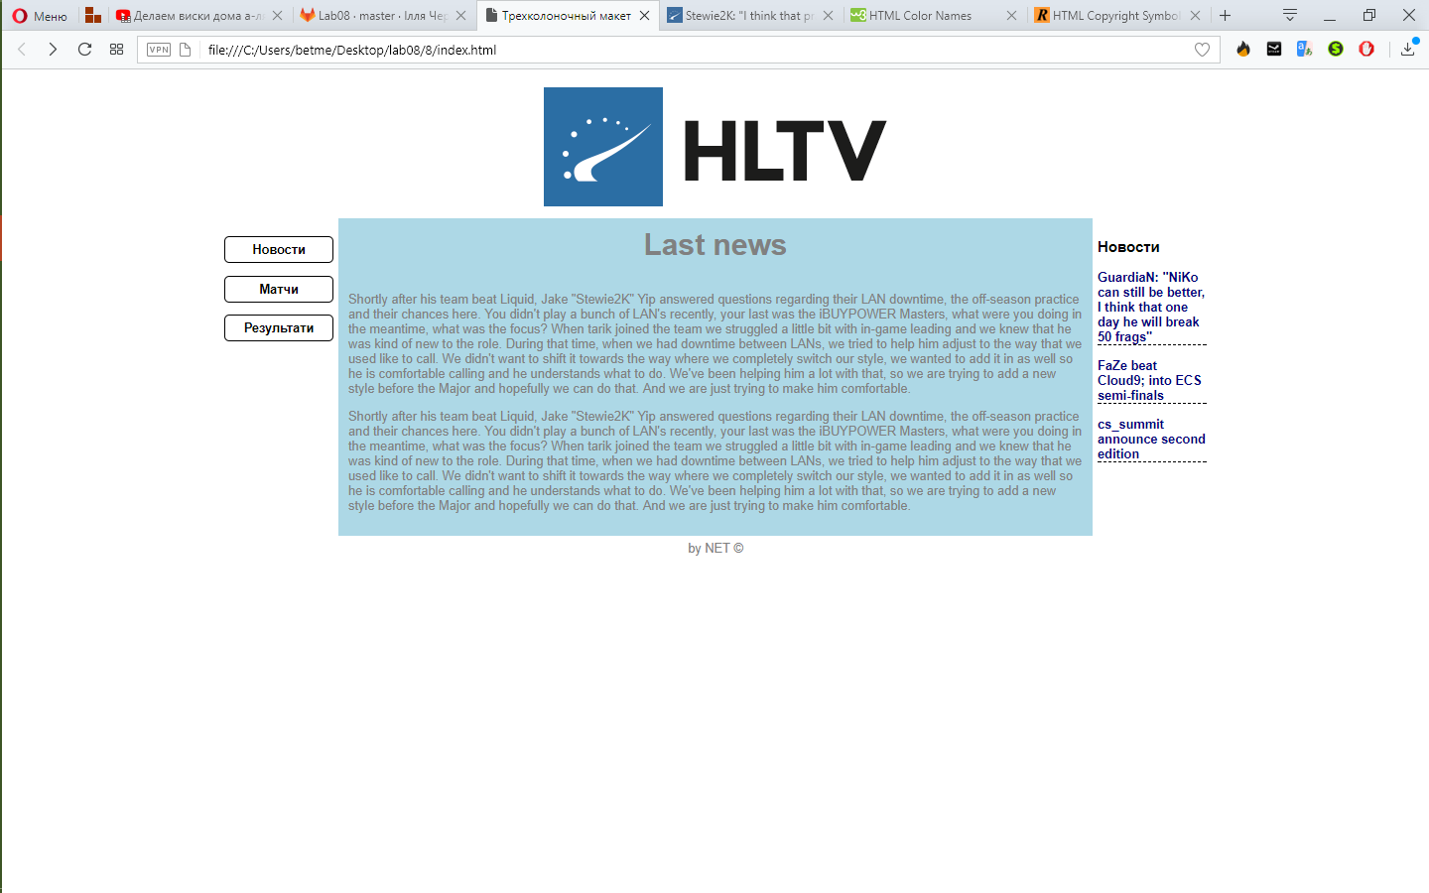
Рис. 8.8 – Вигляд восьмого шаблону

